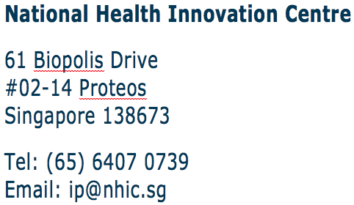

Innovation to Protect (I2P) · Grant Application Form

Date of Application
Your Reference No
Applicant’s Name and Signature
Applicant’s Designation
Institution / Cluster
Office Telephone
Email Address
Stage of I2P Grant Application  (See Annex A for definitions)  (*Please select one only) | Stage 1 – First Filing  Stage 2 – Conversion (PCT)  Stage 2 – Conversion (Regular), Countries: _____________)  Stage 4 – National Phase Entry (NPE), Countries: ________)  Stage 6 – Grant  Others (Please indicate: _____________________________)
Documents Submitted with this Grant Application Form (Ref: NHIC-I2P-1)  (* Please select accordingly) | Invention Disclosure Form (Ref: NHIC-I2P-2) or equivalent  Invention Manuscript  Test Results  Journals and Publications  Prior Art Search Report  Patent Application (for Stage 2, 4 and 6)  Search and Examination Report (for Stage 2, 4 and 6)  Written Opinion Report (for Stage 2, 4 and 6)  Other relevant supporting documents  (Please indicate: __________________________________)
Remarks (if any)

(For NHIC Use only)
NHIC Reference No
Receipt Date

Innovation to Protect (I2P) · Annex A · Stages of Grant Application

First
Filing
Conversion
National
Phase
Entries
Grant
1
2
4
6

3
5
Prosecution
Prosecution

- 1, 2, 4 and 6: The respective healthcare clusters are required to submit their
Invention Disclosures and recommendation to apply for I2P funding.

- 1: Funding quantum for first filing is up to S$5K on provisional
filing.

- 2 and 4: Funding quantum for secondary filing is up to S$40K on
conversion and national phase entries of not more than 2 countries.

- 4: NHIC will fund filing in not more than 2 countries. Filing in more
than 3 countries requires approval by NHIC Oversight Committee on a case-by-case basis.

- 3 and 5: Cumulative office actions > S$20K for any one country will
require additional approval from NHIC Oversight Committee.

SUBMISSION DETAILS

- All applications must be fully endorsed by either the inventors’ respective Office Of Research / Principal’s or Directors’ Office / Agency Headquarters / ED’s Office / Institutes or equivalent.

- Only applications with following two (2) submissions received by the I2P Grant Secretariat will be accepted:

- One softcopy submission containing the above selected documents to be emailed to I2P Grant Secretariat at ip@nhic.sg with the subject header “NHIC I2P_(Name of Healthcare Cluster)_(Name of Inventors’ Institution)”.

- I2P Grant Application Form [NHIC-I2P-1], Invention Disclosure Form [NHIC-I2P-2] or equivalent (One word format without signatures and one PDF format with signatures)

B. One hardcopy submission, with signatures, to be sent and received three (3) working days later from the date of softcopy submission, to the following address:

Attn: I2P Grant Secretariat
National Health Innovation Centre
61 Biopolis Drive #02-14 Proteos
Singapore 138673

Important! : Relevant privileged or confidential information should be disclosed to help convey a better understanding of the application. However, such information must be clearly marked in the application.

